Project Design Phase
Problem – Solution Fit Template
Date | 07 July 2026
Team ID | SWTID-2026-2247
Project Name | Emotion Detection and Learning Support Engine
Maximum Marks | 2 Marks

Problem – Solution Fit Template:
The Problem-Solution Fit simply means that you have found a problem with your customer and that the solution you have realized for it actually solves the customer's problem. It helps entrepreneurs, marketers and corporate innovators identify behavioral patterns and recognize what would work and why.

Purpose:
- Solve complex problems in a way that fits the state of your customers.
- Succeed faster and increase your solution adoption by tapping into existing mediums and channels of behavior.
- Sharpen your communication and marketing strategy with the right triggers and messaging.
- Increase touch-points with your company by finding the right problem-behavior fit and building trust by solving frequent annoyances, or urgent or costly problems.
- Understand the existing situation in order to improve it for your target group.

Template:
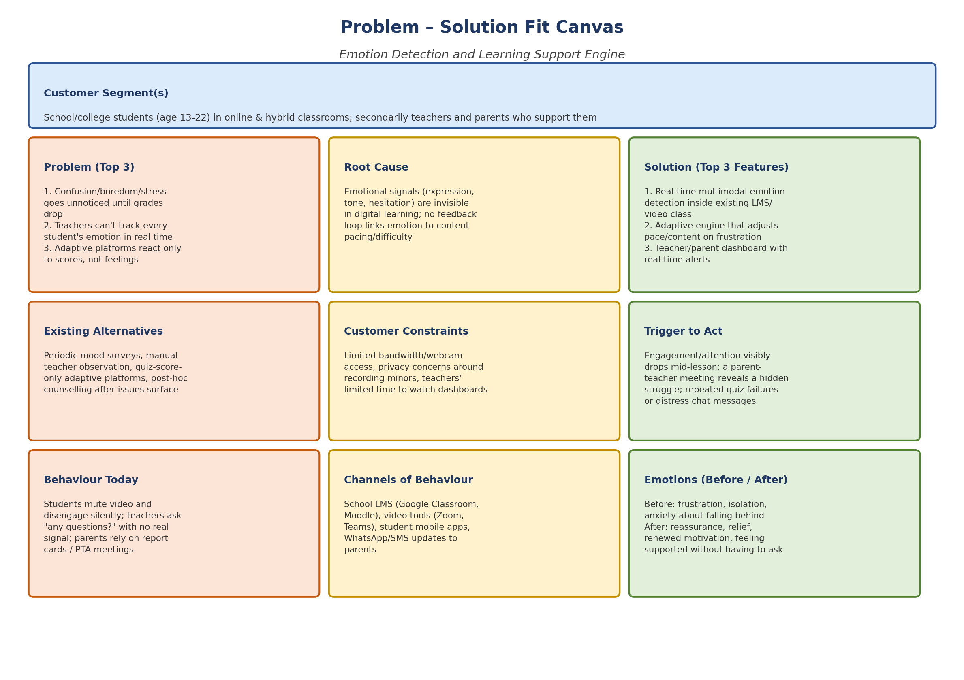

Problem – Solution Fit Details:
Customer Segment(s): School/college students (age 13-22) in online & hybrid classrooms; secondarily teachers and parents who support them
Problem (Top 3)  - Confusion, boredom, or stress goes unnoticed until grades drop  - Teachers cannot track every student's emotional state in real time  - Adaptive platforms react only to quiz scores, not to how the student feels | Root Cause / Constraints  - Emotional signals (expression, tone, hesitation) are invisible in digital learning  - No feedback loop links emotion to content pacing or difficulty  - Limited bandwidth/webcam access and privacy concerns around recording minors | Solution (Top 3 Features)  - Real-time multimodal emotion detection built into the existing LMS/video class  - Adaptive learning engine that adjusts pace/content the moment frustration is detected  - Teacher/parent dashboard with real-time alerts and weekly trend reports
Existing Alternatives  - Periodic self-report mood surveys / check-ins  - Manual teacher observation in class  - Quiz-score-only adaptive learning platforms  - Post-hoc counselling after a student is already flagged | Channels of Behaviour  - School LMS: Google Classroom, Moodle  - Video conferencing: Zoom, MS Teams  - Student mobile apps used outside class  - WhatsApp/SMS updates to parents | Trigger to Act  - Engagement/attention visibly drops mid-lesson  - A parent-teacher meeting reveals a hidden struggle  - Repeated quiz failures or a distress message in chat
Behaviour Today  - Students mute video and disengage silently  - Teachers ask "any questions?" and get no real signal  - Parents rely on report cards / periodic PTA meetings |  | Emotions (Before / After)  - Before: frustration, isolation, anxiety about falling behind  - After: reassurance, relief, renewed motivation, feeling supported without having to ask

